Brian Engel

Module 3 Milestone

Import database

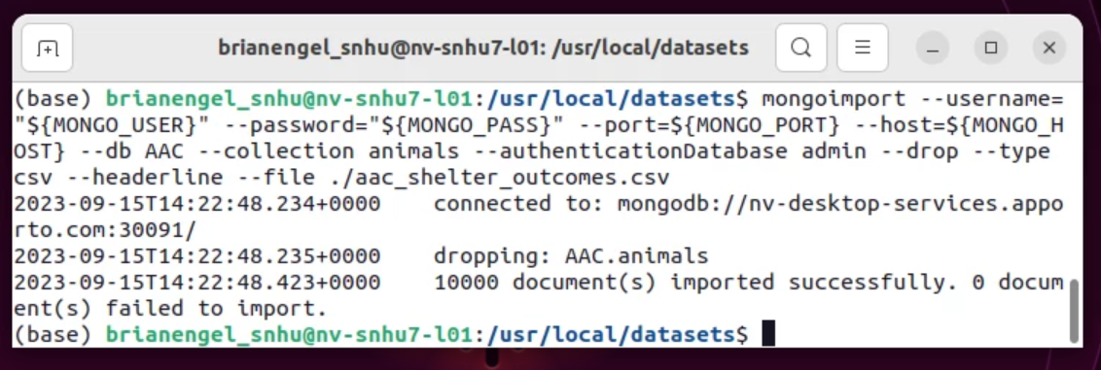

Create breed index

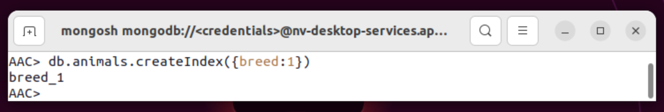

Query with explain

I ran the find function with explain execution stats and no field to find out how many fields a normal search would look through first – 10000.

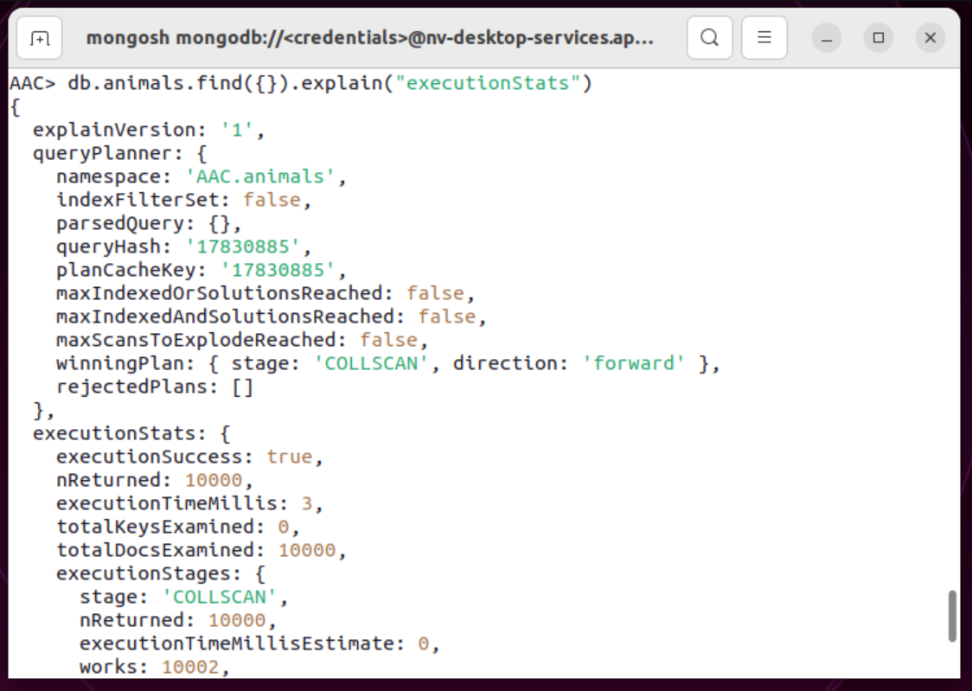

Then I ran the same command but with the indexed breed field to compare the 2. Breed index is only 801 for pit bull mix.

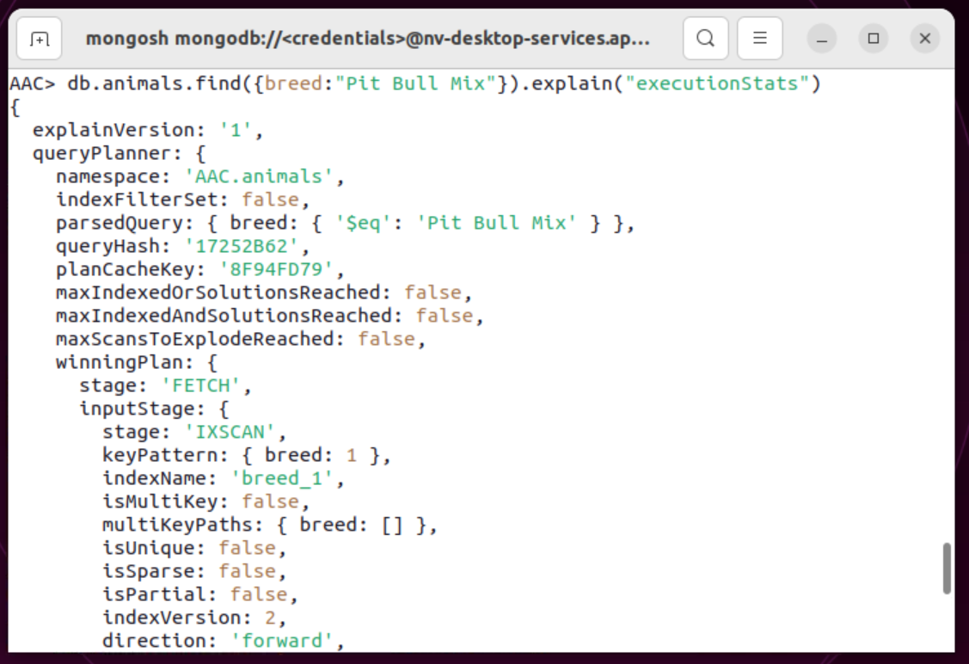

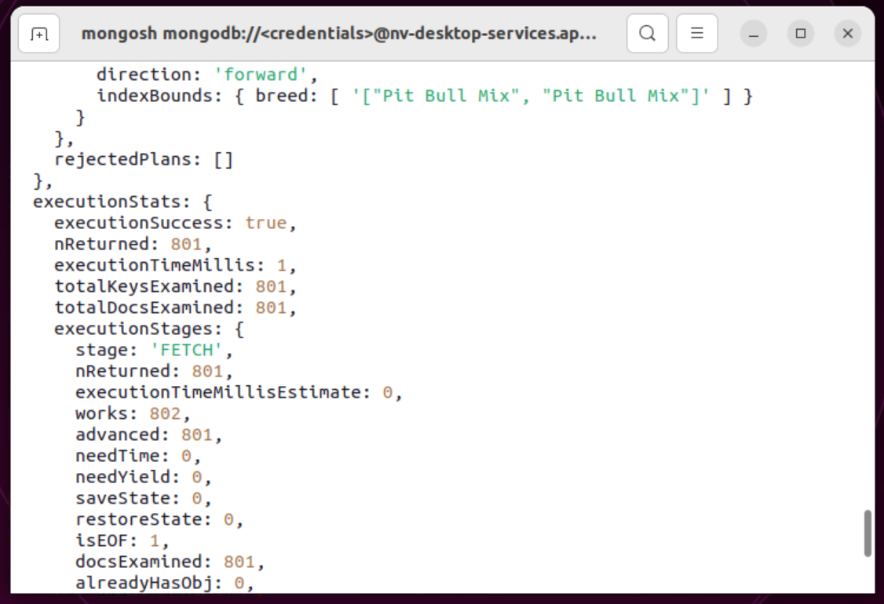

Create compound index

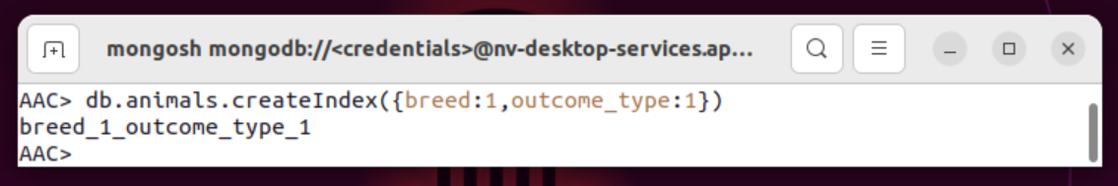

I search for breed of pit bull mix with outcome_type of transfer since I already know the amount of documents searched for just pit bull mix. The compound index brought the amount of documents searched down to 145.

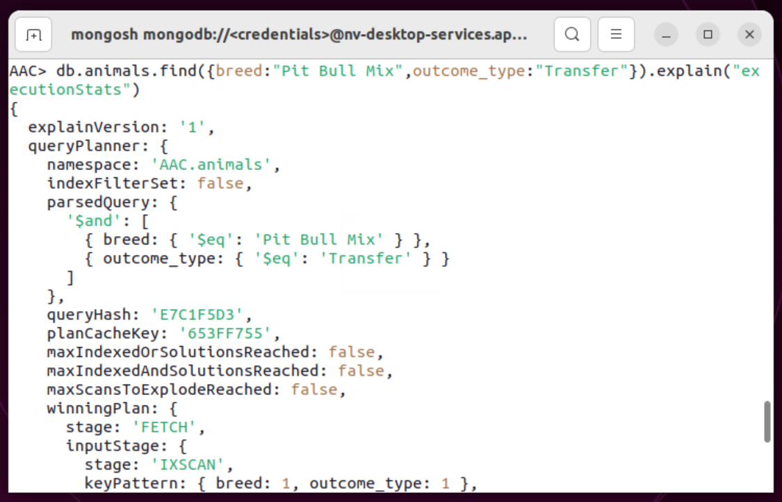

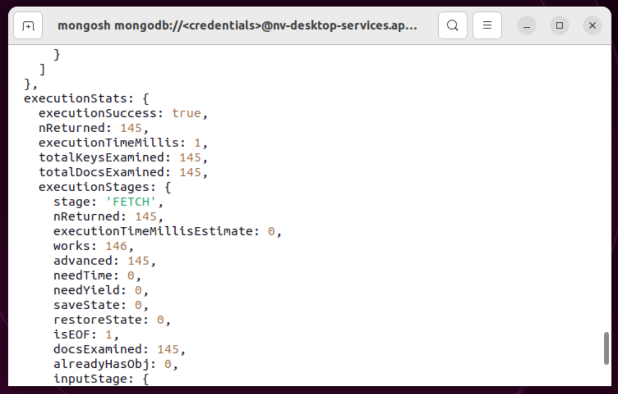

Create new user “aacuser” password “password1”

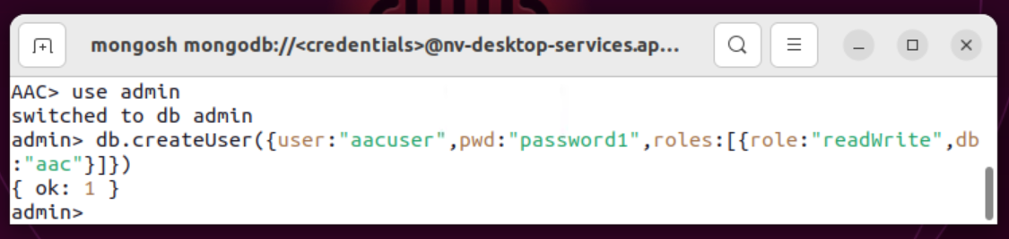

Switch to new account in new window

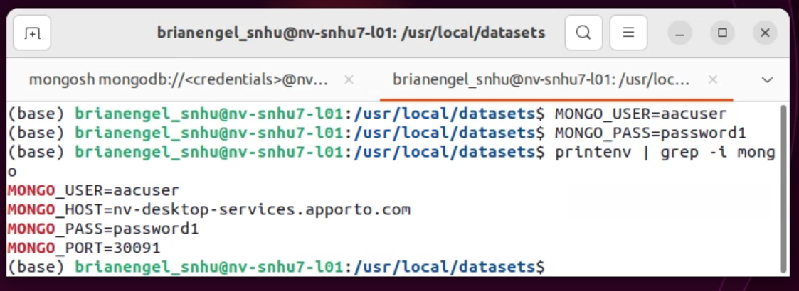

Login to mongoDB shell with aacuser

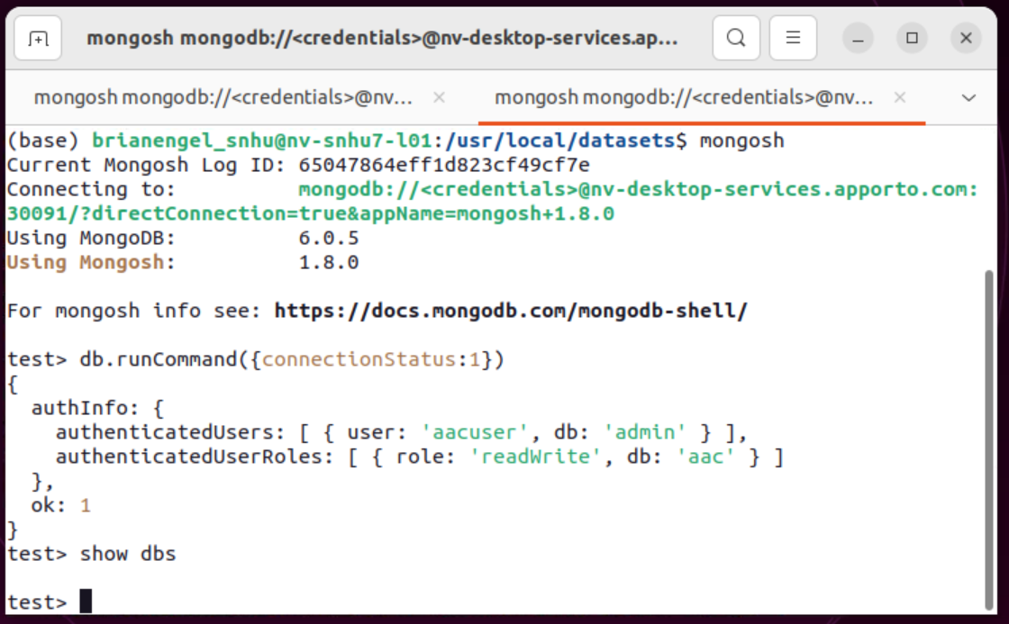

Login to mongoDB shell with user root

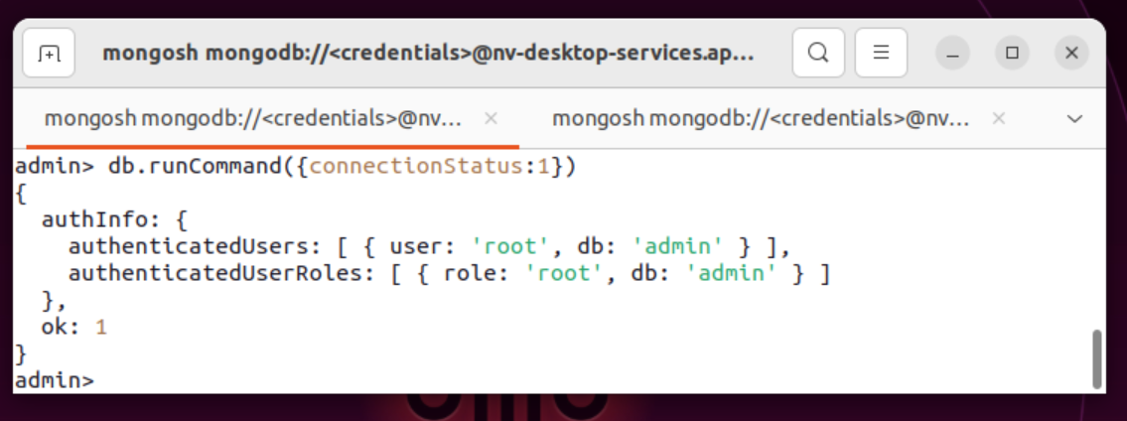

Show users

